LECTURE SERIES · ISEA
Intelligent Digital Forensics: LLMs, NLP, and Explainable AI for Cyber Investigations
Session 8 Lab Manual
Threat Intelligence Extraction and Summarisation

Extract by rule. Summarise by model. Never the other way round.

Two labs, thirty minutes each. No coding background assumed: every step is written out and every expected output printed here was produced by actually running the notebook against live public feeds.
Companion notebook: ISEA_S8_cti_extraction.ipynb
Companion deck: Session8_HandsOn_Concise.pptx
Corpus: CISA joint advisory AA26-204A
CISA AA26-204A advisory
CISA Known Exploited Vulnerabilities JSON feed
For the first, save the advisory text as advisory.txt. Save the second exactly as known_exploited_vulnerabilities.json.
Runtime: Google Colab, CPU.

Before the session — five minutes of setup
TIME  5 min | NEEDS  A Google account and a browser | YOU PRODUCE  A running notebook with four live feeds loaded

1. You have been given the notebook file ISEA_S8_cti_extraction.ipynb. Open https://colab.research.google.com , sign in with a Google account, then choose File → Upload notebook and select that file. (If the facilitator has shared a Drive link instead, opening it does the same thing.)
2. Choose File → Save a copy in Drive. Work in your copy.
3. Check Runtime → Change runtime type → CPU. No GPU needed.
4. Run Section 0. Four network calls; the EPSS download is the slow one.
Expected (your figures will differ slightly)
advisory : 72,043 characters
KEV : 1,662 entries, released 2026-08-07

Plan B — if the CISA fetch fails
Corporate networks and some jurisdictions block cisa.gov. Two fallbacks, in order:
1. Phone hotspot for ninety seconds. Once the advisory text is in the Colab session you can switch back.
2. Ask the facilitator for advisory.txt. Upload it with the folder icon in the Colab sidebar, then skip the fetch and run from Section 1.
The NVD API is also rate-limited to five requests per thirty seconds without a key. The notebook sleeps between calls; do not remove those sleeps.

Lab 1 — Extract by rule
TIME  30 min · solo | NEEDS  Sections 1–3 of the notebook | YOU PRODUCE  An extraction, a filled pyramid, three prioritisation answers

The question this lab answers: which half of your pipeline is allowed to be probabilistic? The answer is the half a human reads — never the half that gets actioned.

Part A — Run both extractors and count what you lost (11 minutes)
1. Run Section 1. It applies a standard IOC regex set to the advisory text.
2. Look at the IP count before you go on.
Expected — the naive pass
ipv4 0
domain 10
sha256 5
md5 0
cve 1
attack 36

What just happened
An advisory that describes adversary infrastructure across dozens of paragraphs reported zero IP addresses. The regex is correct. The assumption behind it is not.
Advisories defang indicators on purpose — so a reader cannot click a live malicious link by accident, and so the document does not trip a mail filter. 1.2.3[.]4 is not an IPv4 address to a pattern matcher; it is a string with brackets in it.

3. Run the refang cell, then the comparison.
SECTION 1 — the fix is one substitution, applied before extraction
def refang(text):
text = re.sub(r"\[\.\]|\(\.\)|\{\.\}", ".", text)
text = re.sub(r"\[:\]", ":", text)
text = re.sub(r"\bh(?:xx|XX)(p|ps)\b", r"htt\1", text, flags=re.I)
text = re.sub(r"\[(?:at|@)\]", "@", text, flags=re.I)
return text

aware = extract(refang(TEXT)) # refang first, extract second

Expected
naive refanged missed
ipv4 0 9 9
domain 10 19 9
sha256 5 5 0
md5 0 0 0
cve 1 1 0
attack 36 36 0

network indicators: 10 of 28
naive recall = 35.7%

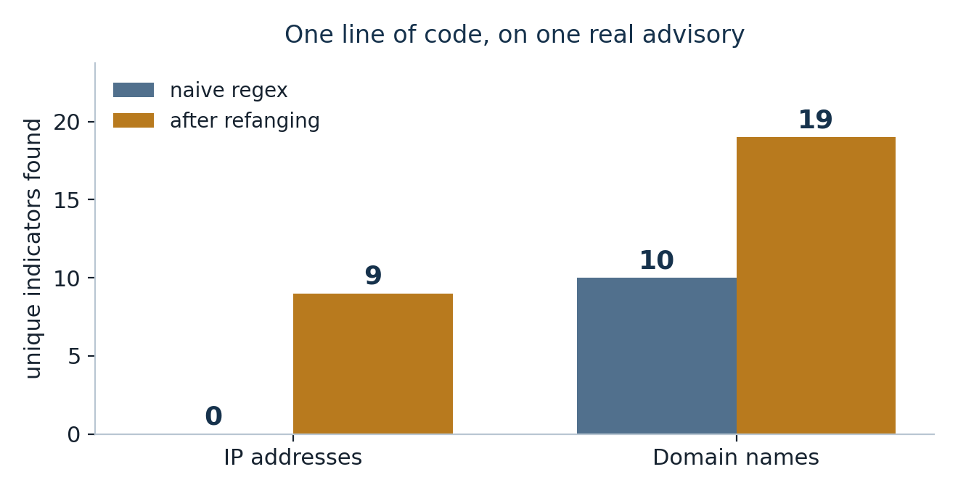
Figure 1 — one line of code, on one real advisory.
What just happened
Hashes and technique IDs are unaffected — they contain no dots to defang. The entire loss is in the network indicators, which is the half that gets pushed into blocklists.
A pipeline built the naive way does not error. It reports ten indicators, cleanly, every day. The failure is silent, and the only way to notice is to read the source yourself — which is the reading the automation was bought to save you.
That is the shape of most extraction failures: not wrong output, but confidently incomplete output.

Checkpoint A
You can state the naive recall figure (35.7% on the day this was written) and explain in one sentence why hashes were unaffected.

The instruction that transfers
Test your extractor once against a document you have read by hand. It takes an hour, and it is the only way this class of failure ever surfaces. Coverage metrics will not show it — the counts look normal.

Part B — Fill the pyramid (11 minutes)
Bianco's Pyramid of Pain (2013). The vertical axis is not importance — it is how much it costs the adversary to change. A hash dies when one byte changes. An IP is trivially rotated and is often shared with innocent parties. Changing how you work is expensive, slow and visible.
1. Run Section 2. It buckets everything you extracted into the six tiers.
Expected
TTPs (ATT&CK techniques) 36
Tools 0
Network / host artefacts 0
Domain names 19
IP addresses 9
Hash values 5

below the line (cheap to change): 33
above the line (expensive) : 36
share below the line: 47.8%

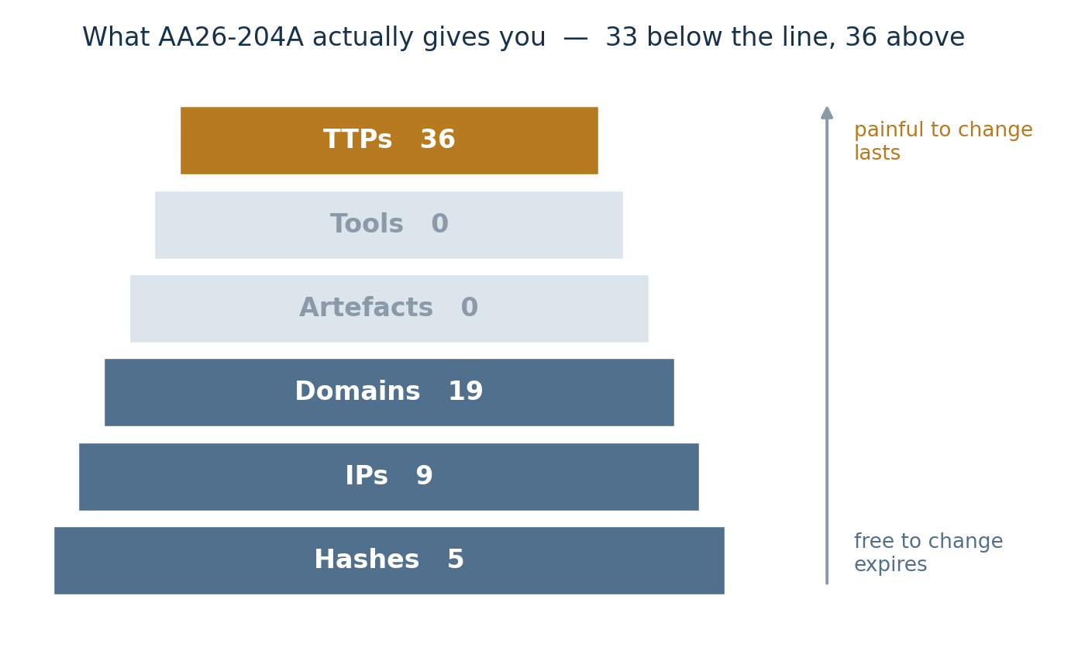
Figure 2 — the pyramid, filled with what this advisory actually contains.
Two things to write down
1. This advisory is unusually good: 36 technique IDs against 33 bottom-tier indicators, so roughly half its extractable value sits above the line. Most commercial indicator feeds are 100% bottom three tiers, because that is the part that is cheap to produce at volume. Do not leave thinking advisories are generally this rich.
2. A feed priced per indicator is priced by the tier that expires fastest. That is not an accident, and it is worth saying in a procurement conversation.

Checkpoint B
You can name which tier a hash sits in, why detection built on behaviour lasts longer, and what that implies about a feed sold by volume.

Part C — Three questions, three answers (8 minutes)
Severity, exploitation and risk are three different variables that get collapsed into one number constantly. Run Section 3.
Expected (live figures — yours will differ)
CVEs rated CRITICAL : 30,466
...of which known exploited : 479 (1.57%)
Known exploited, total : 1,662
...NOT rated critical : 1,183 (71.2%)

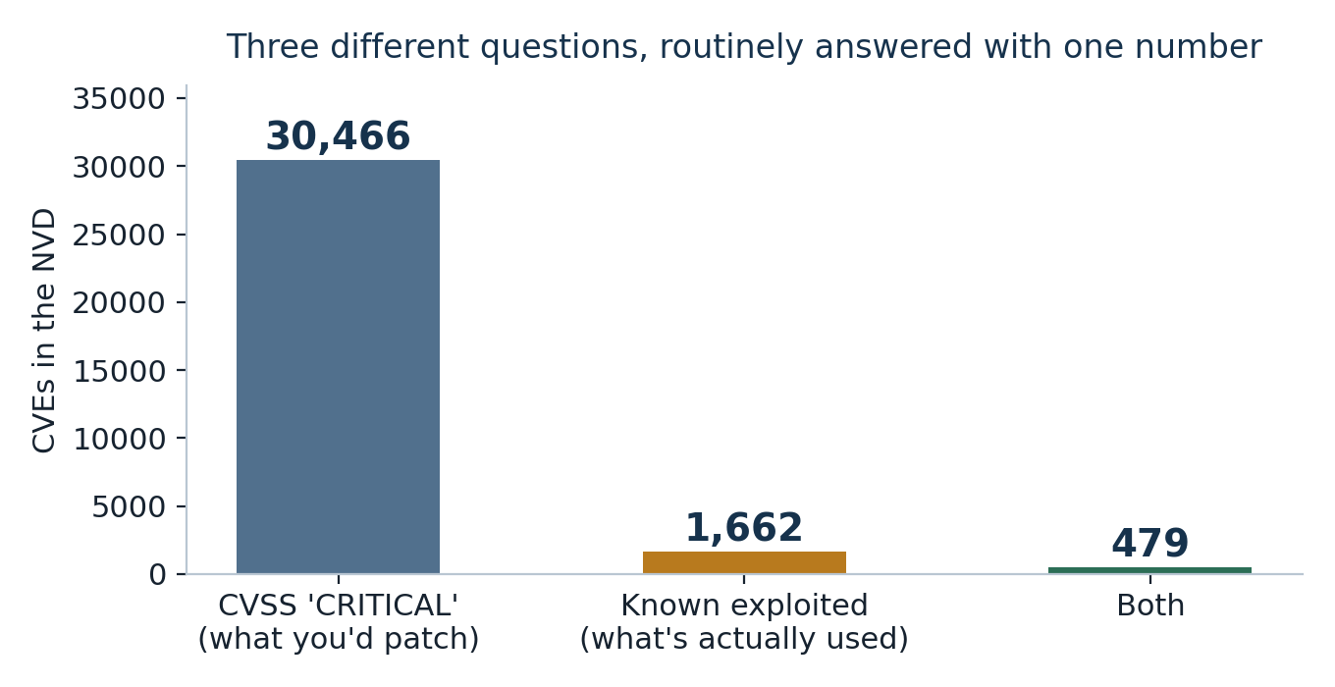
Figure 3 — three different questions, routinely answered with one number.
Signal | What it answers | What it is
CVSS | How bad would it be if exploited? | An intrinsic property of the flaw. Says nothing about whether anyone is exploiting it.
EPSS | How likely is exploitation? | A prediction, rescored daily.
KEV catalogue | Was it actually exploited? | An observation — and a floor, not a census.
Your risk | Does it matter to us? | None of the above. Depends on what you run, what is exposed, and what it protects.

Be fair to EPSS
Its top 1,662 captures 641 known-exploited CVEs (38.6%), and the median EPSS percentile of a known-exploited CVE is 98.9. That is genuinely good, and far better than CVSS.
But it remains a prediction. Only the KEV catalogue records something that happened — and even that lists what was observed and reported, not everything that occurred. Absence from KEV is not evidence of absence of exploitation.

Write in your worksheet: pick one CVE from the advisory, get its severity, its KEV status and its EPSS score, then one sentence — which of the three would you actually brief, and to whom?
Checkpoint C
You can explain why patching strictly by CVSS is expensive and incomplete at the same time, using your own two numbers.

Lab 2 — Summarise by model, then prove it invented nothing
TIME  30 min · solo | NEEDS  Sections 4–7, plus a ChatGPT tab | YOU PRODUCE  An LLM summary, a fabrication report, a rewritten claim

The harness, before you need it (Section 4)
This is the whole defence, and it is four lines. Build it once and put it between your model and anything that writes to an enforcement system.
SECTION 4 — the audit harness
TRUTH = extract(refang(TEXT))

def audit(summary_text):
claimed = extract(refang(summary_text))
return {kind: sorted(vals - TRUTH[kind]) for kind, vals in claimed.items()}

Two test fixtures, and who wrote them
The notebook contains two short summaries to prove the harness works before you trust it. I wrote both by hand — they are not model output, and the notebook does not pretend otherwise.
The first is clean. The second contains one manufactured hash and one manufactured CVE — format-valid, plausible, and untraceable, which is exactly what a hallucinated indicator looks like.
One warning worth more than the fixture itself. The obvious way to build a fake CVE is to take a real one and add one to the last digit. Do not. While this material was being written, that trick applied to CVE-2025-66376 produced CVE-2025-66377 — a real, unrelated vulnerability. A hallucinated identifier does not always fail loudly; sometimes it resolves, and a team patches the wrong product and reports the work done. The notebook uses CVE-2025-99999, which returns zero results from the NVD API. A 256-bit hash is different: the space is large enough that changing one character will not collide with anything.

Expected
--- clean fixture ---
sha256 claimed 1 traced 1
cve claimed 1 traced 1
0 indicator(s) could not be traced to the source document.

--- fixture with two manufactured indicators ---
sha256 claimed 2 traced 1 <-- FABRICATED
cve claimed 2 traced 1 <-- FABRICATED
2 indicator(s) could not be traced to the source document.

Part A — Generate the summary (10 minutes)
1. Run Section 5. It prints a grounded prompt built from your extraction.
2. Choose one audience — a SOC engineer or a board member — and edit AUDIENCE before running.
3. Paste the prompt into ChatGPT. Record the model, version and date.

Part B — Run the harness, then read what it passed (12 minutes)
1. Paste the summary into Section 6 between the triple quotes and run. The set-difference is automatic.
2. Then do the half the harness cannot do.
What the harness catches, and what it does not
It catches manufactured indicators — strings that appear in the summary and nowhere in the source.
It cannot catch a real indicator described wrongly. If the summary calls an address adversary infrastructure when the advisory listed it as a compromised victim, every string checks out and the meaning is inverted. Blocking that one breaks production.
That failure needs a human who read the source — which is the reading the summariser was supposed to save. Automate the check you can automate, and be honest that it is a floor and not a ceiling.

For each indicator the harness passed, open advisory.txt and check how the source describes it:
Category | The question to ask
Adversary infrastructure | Did the advisory say this was attacker-controlled?
Compromised third party | Or a victim whose systems were abused?
Example / documentation | Or an illustration the author invented?
Unstated | Did the advisory simply list it without saying which?

Checkpoint D
You can report two separate counts: how many indicators the harness flagged, and how many it passed that you still had to correct by reading. The second number is the one that shows you did Part B properly.

Part C — Rewrite one sentence properly (8 minutes)
Take the summary's central claim and rewrite it with a likelihood term from a stated scale and a separate confidence statement about the evidence.
A worked example
“The campaign described in AA26-204A is highly likely to be ongoing against similar targets. Confidence: moderate — the assessment rests on a single government advisory with no independent corroboration available to us, and we have not observed the described activity on our own estate. Likelihood scale: almost certainly (>90%) / highly likely (75–90%) / likely (55–75%) / roughly even chance (45–55%) / unlikely (25–45%) / highly unlikely (<25%).”
Two separate axes. “Highly likely, moderate confidence” is a coherent and common position — collapsing them into “we believe” destroys both.

Why this is not pedantry
“Possible” has been shown to mean anything from five per cent to eighty per cent depending on the reader. If your report drives a spending decision, that spread is the decision. State the scale, once, in an annex — then a reader in another organisation reads your word the way you meant it.

Appendix A — Self-check
Six questions. Answers overleaf — cover them until you have written yours.
1. Your enrichment pipeline reports a healthy number of indicators from every advisory it ingests. What single test would tell you whether it is silently dropping half of them?
2. Why are hashes and ATT&CK technique IDs unaffected by defanging, when domains and IP addresses are not?
3. A vendor offers you a feed of two million indicators for a fixed annual price. Using the Pyramid of Pain, what is the first question you ask?
4. A CVE has CVSS 9.8 and is not in the known-exploited catalogue. A second has CVSS 6.1 and is. Which do you patch first, and what else do you need to know before answering?
5. Your audit harness passes every indicator in an LLM summary. Name a failure it cannot have caught.
6. Why does 'extract by rule' also happen to be a defence against prompt injection?

Appendix A answers
1. Run your extractor over one advisory you have also read by hand, and compare. Nothing in a dashboard will show this, the counts look normal either way. On AA26-204A the naive extractor reported 10 network indicators against a true 28, and every single IP address was missing.
2. Defanging inserts characters into the delimiters that make an address an address — the dots in a domain or IP, the colon and scheme in a URL. Hashes are a continuous run of hexadecimal with no delimiters to break, and technique IDs are a letter followed by digits. There is nothing in either for the convention to alter.
3. Something close to: which tiers of the pyramid does this cover, and in what proportion? Two million indicators is almost certainly hashes, IPs and domains, the bottom three tiers, where the adversary defeats them for free and where volume is cheap to produce. Volume is a poor proxy for value, and per-indicator pricing rewards exactly the tier that expires fastest.
4. You cannot answer from those two numbers alone, and that is the point of the question. Confirmed exploitation is a stronger signal than predicted severity, so the 6.1 has a real claim on your attention. But neither figure is your risk: you need to know whether you run each product, whether it is exposed, and what it protects. A CVSS 10 in software you do not deploy is a zero for you.
5. A real indicator described wrongly. Every string traces to the source, so set-difference passes it, while the meaning is inverted, for example an address the advisory listed as a compromised third party presented as adversary infrastructure. Acting on that one breaks somebody else's production. It can only be caught by a human reading the source.
6. Because a regex cannot be instructed. Text collected from an adversary-controlled source may contain instructions aimed at a model in your pipeline, but a deterministic extractor has no instruction-following surface, it either matches a pattern or it does not, so injected text cannot manufacture an indicator. Keeping the actioned half of the pipeline deterministic is an architectural defence, not just a quality choice.

Appendix B — Glossary
Term | Meaning
IOC | Indicator of compromise: an observable such as a hash, address or domain associated with malicious activity.
Defanging | A documentation convention that breaks indicators so they cannot be clicked or auto-linked, e.g. 1.2.3[.]4 and hxxp://.
Refanging | Reversing that convention before extraction. One substitution; the whole of Lab 1 Part A.
Pyramid of Pain | Bianco's model ranking indicator types by how costly they are for the adversary to change.
TTPs | Tactics, techniques and procedures, that is how an adversary works, as opposed to what they used.
MITRE ATT&CK | A catalogue of adversary techniques observed in the wild. Technique IDs look like T1566.001.
CVSS | Common Vulnerability Scoring System. Measures intrinsic severity, not exploitation.
EPSS | Exploit Prediction Scoring System. Estimates the probability of exploitation. A prediction, rescored daily.
KEV | CISA's Known Exploited Vulnerabilities catalogue. A record of observed in-the-wild exploitation.
STIX / TAXII | The structured format for expressing threat intelligence, and the protocol for exchanging it.
Estimative language | A fixed vocabulary for expressing likelihood, published with the report so a reader can decode it.
Prompt injection | Text in a collected document treated as instruction by a model that was only meant to read it as data.

Appendix C — Sources
- Bianco, D. (2013) — The Pyramid of Pain. The prioritisation model used throughout Lab 1. https://detect-respond.blogspot.com/2013/03/the-pyramid-of-pain.html
- MITRE ATT&CK — Enterprise tactics and techniques catalogue. The mapping target for technique IDs. https://attack.mitre.org/
- CISA — Known Exploited Vulnerabilities Catalog. Observation of in-the-wild exploitation. https://www.cisa.gov/known-exploited-vulnerabilities-catalog
- FIRST — Exploit Prediction Scoring System (EPSS). https://www.first.org/epss/
- FIRST — Common Vulnerability Scoring System (CVSS) v3.1 specification. https://www.first.org/cvss/v3.1/specification-document
- NVD — National Vulnerability Database, used for the severity counts in Lab 1 Part C. The API endpoint the notebook calls: https://services.nvd.nist.gov/rest/json/cves/2.0 · the developer documentation lives at nvd.nist.gov/developers/vulnerabilities, which was returning a 502 from the NIST web front-end when this manual was built.
- CISA advisory AA26-204A — “Russian State-Supported Cyber Actors Conduct Phishing Campaign Targeting Users of Zimbra Collaboration Suite” — the extraction corpus for both labs. https://www.cisa.gov/news-events/cybersecurity-advisories/aa26-204a
- Kent, S. — Words of Estimative Probability. The origin of estimative language in intelligence writing. https://www.cia.gov/resources/csi/studies-in-intelligence/archives/vol-8-no-4/words-of-estimative-probability/
- Lockheed Martin — Intelligence-Driven Computer Network Defense (the Cyber Kill Chain). https://www.lockheedmartin.com/en-us/capabilities/cyber/cyber-kill-chain.html
- Caltagirone, Pendergast & Betz (2013) — The Diamond Model of Intrusion Analysis. https://www.activeresponse.org/wp-content/uploads/2013/07/diamond.pdf

Appendix D — Facilitator notes

The night before
1. Run the whole notebook on the venue wifi. Four network calls, one of them to a .gov domain — the most likely thing to be blocked.
2. Save advisory.txt to a USB stick as the offline fallback.
3. Re-read the deck's live figures against what the notebook prints today, and correct them verbally if they have moved. Say out loud that they moved — it makes the point better than the slide does.
4. Run the Section 5 prompt through ChatGPT yourself so you know what kind of draft the room will get and whether it fabricates anything today.

Run of show
Clock | Segment | What you are doing
0:00 | Open + Exhibit A | Two format-valid strings; ask which is real. Nobody can tell. Do not resolve it immediately.
0:04 | Case study | WannaCry and Log4Shell. Both had adequate intelligence and bad outcomes.
0:10 | Micro-teach A | Six slides, hard stop. The Pyramid and the severity slide are non-negotiable.
0:25 | Lab 1 | Circulate during Part A. The naive IP count is where the conversation starts.
0:55 | Debrief A | The silent-failure question. Two answers, no more.
1:03 | Micro-teach B | Five slides. Prompt injection and estimative language both earn their place.
1:18 | Lab 2 | Protect the second half of Part B — the meaning check is what people skip.
1:48 | Debrief B | What did the harness flag? What did it pass that was still wrong?
1:55 | Close | Four carry-outs. Hand forward to Session 9.

Scoreboard — one row per participant
Column | Expected value
Name
L1 naive network indicators | 10
L1 refanged network indicators | 28
L1 naive recall | 35.7%
L1 pyramid bottom share | 47.8%
L1 which signal you would brief | free text — should not be CVSS alone
L2 audience chosen | SOC engineer or board member
L2 model + version + date | free text — check it is actually filled in
L2 indicators flagged by harness | 0 or more; 0 is a legitimate result
L2 indicators miscategorised | ≥ 1 in most runs; this is the number that shows they read the source
Rewritten claim | must carry a likelihood term AND a separate confidence statement

Three things to say out loud, all of them honest
1. The figures are live and will have moved since the deck was built. Show the difference rather than hiding it.
2. The two audit fixtures in Section 4 were written by hand as test cases, not produced by a model. The notebook says so; say it too.
3. This advisory is unusually TTP-rich (36 techniques). Most feeds are entirely bottom-tier. Without that caveat the room leaves with the wrong impression of the average advisory.

If the room is ahead of schedule
Three discussion questions, in increasing difficulty:
1. If a Log4Shell-class flaw were announced this afternoon, how long before you could answer whether you run it, and where? The honest answers are measured in days.
2. Your triage pipeline reads adversary-controlled text and passes it to a model. Draw the trust boundary. Where does the deterministic half end?
3. You have no way to score whether your intelligence was any good, because nobody reports the attack that did not happen. What would you have to record today for a future reader to judge you fairly?

